Database week 3

**Challenge 1.1: Total Spent per Category**

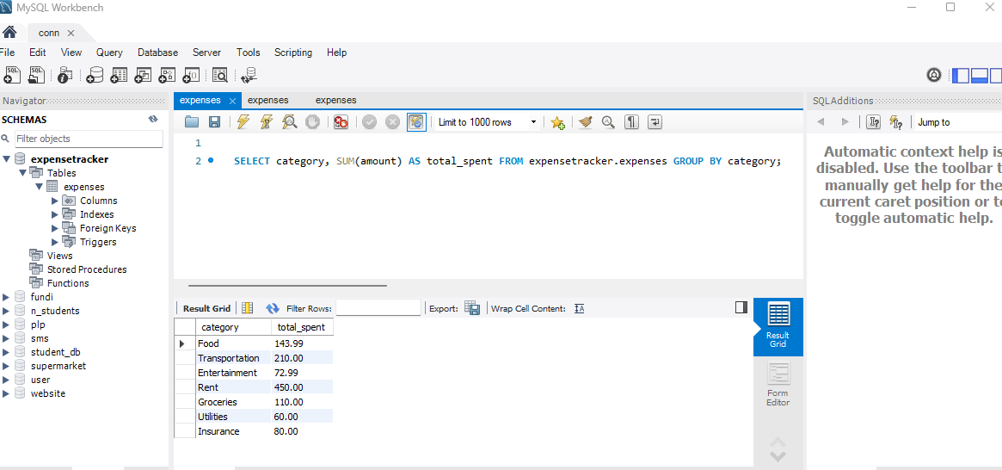

**Challenge 1.2: Average Expense per Category**

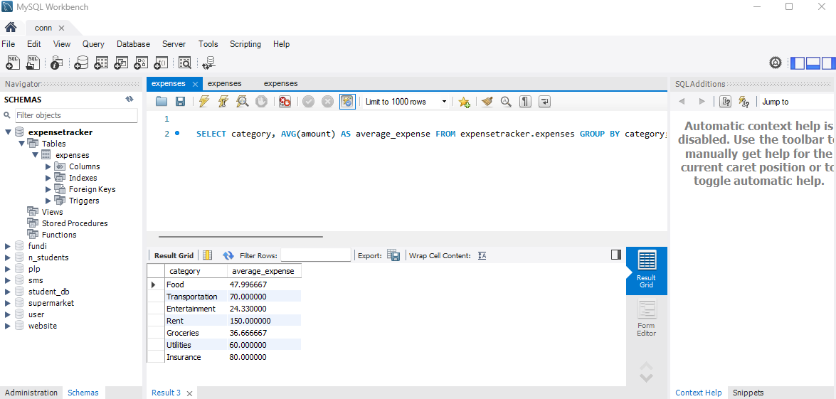

**Bonus Challenge (Optional): Top Spending Categories**

